ELECTRONIC DOCUMENT PARATION AND MANAGEMENT

12
THE COMPUTER SYSTEM
FUNDAMENTALS OF COMPUTING

THE COMPUTER SYSTEM
CONTACT
MR. TORY O. ROBINSON
edpm_edu_magghigh@yahoo.com
http://edpmclass.yolasite.com
1-876-819-2489
The computer has become the most useful piece of equipment in the modern office environment. The computer not only makes work easier but all so help to produce creative and acceptable documents. In the modern office the computer is used not only for typing but also to store and transmit documents.
A computer can be defined as an electronic device that accepts data, process the data to produce meaningful information.

CLASSIFICATION OF COMPUTERS
SUPERCOMPUTERS:
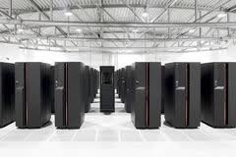
Supercomputer is a broad term for one of the fastest computers currently available. Supercomputers are very expensive, take up a lot of floor space and are employed for specialized applications that require immense amounts of mathematical calculations (number crunching). For example, weather forecasting requires a supercomputer. Other uses of supercomputers scientific simulations, (animated) graphics, fluid dynamic calculations, nuclear energy research, electronic design, and analysis of geological data (e.g. in petrochemical prospecting).

MAINFRAME COMPUTERS: Mainframe was a term originally referring to the cabinet containing the central processor unit or "main frame" of a room-filling Stone Age batch machine. Nowadays a Mainframe is a very large and expensive computer capable of supporting hundreds, or even thousands, of users simultaneously. The chief difference between a supercomputer and a mainframe is that a supercomputer channels all its power into executing a few programs as fast as possible, whereas a mainframe uses its power to execute many programs concurrently. In some ways, mainframes are more powerful than supercomputers because they support more simultaneous programs. But supercomputers can execute a single program faster than a mainframe.
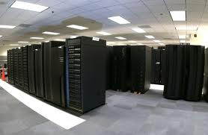

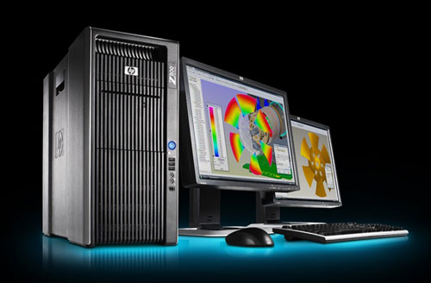
MINICOMPUTERS/WORKSTATIONS: It is a type of computer used for engineering applications (CAD/CAM), desktop publishing, software development, and other types of applications that require a moderate amount of computing power and relatively high quality graphics capabilities. Workstations generally come with a large, high-resolution graphics screen, at large amount of RAM, built-in network support, and a graphical user interface. Most workstations also have a mass storage device such as a disk drive, but a special type of workstation, called a diskless workstation, comes without a disk drive. The most common operating systems for workstations are UNIX and Windows NT. Like personal computers, most workstations are single-user computers. However, workstations are typically linked together to form a local-area network, although they can also be used as stand-alone systems.

MICROCOMPUTERS/PERSONAL COMPUTERS: Can be defined as a small, relatively inexpensive computer designed for an individual user. In price, personal computers range anywhere from a few hundred pounds to over five thousand pounds. All are based on the microprocessor technology that enables manufacturers to put an entire CPU on one chip. Businesses use personal computers for word processing, accounting, desktop publishing, and for running spreadsheet and database management applications. At home, the most popular use for personal computers is for playing games and recently for surfing the Internet. Personal Computers also include the following: Notebooks, Laptops, PDA, Palmtop, Tablets.

DESKTOP COMPUTER LAPTOP COMPUTER
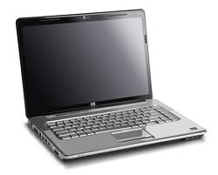
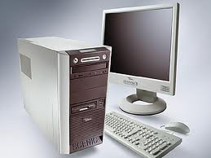
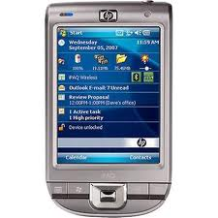

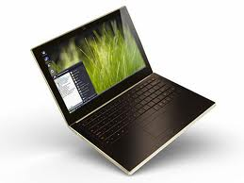
PDA COMPUTER NOTEBOOK COMPUTER

TABLET COMPUTER
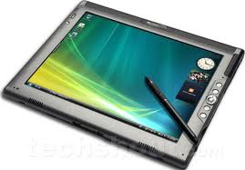

HARDWARE

Hardware refers to the tangible components of a computer system (the parts of the computer that can be seen and touched)

Examples of these are: mouse, keyboard, monitor, scanners, etc.

Devices:

Categories of computer devices:

- Input
- Output
- Storage

INPUT DEVICES: These are any peripheral device that is connected to the computer system that allows the user to send data into the computer system.

Now let us look at some examples of input devices:

- Keyboard –
- Mouse
- Light Pen
- Microphone
- Scanners
- Barcode Readers
- Optical Character reader, etc

OUTPUT DEVICES: These are any peripheral device that is connected to the computer system that allows the user to produce meaningful information (printed of soft copy).

Examples of output devices:

- Printers 5. Multimedia projectors, etc.
- Plotters
- Speakers
- Monitors
PRINTERS

Let us now look at the different types of printers:

Printers are categorized under two main heading impact and non-impact printers.

Let us now look at the impact printers.

IMPACT PRINTERS:

These printers create text or image by physically make the print head to press the ink ribbon and cause the ink deposition on the paper in desired form is called impact type. Normally it is quite louder in nature when compared to other types of printers. The well known example for impact type is Dot Matrix and Daisy wheel.
These printers are normally utilized in businesses where multi-forms are printed. For example hospital bills, pay invoice, sales invoice, etc
Dot Matrix Printer Daisy Wheel Printer
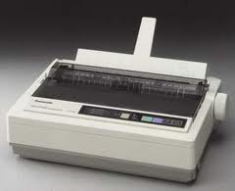
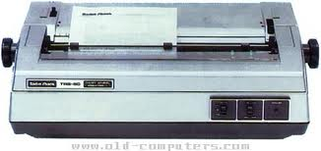

NON-INPACT PRINTER:

These printers produce text or images on paper without striking the paper physically are called as non-impact type. These are not louder when compared to other types of printers. The well known example of this type is Thermal printer, lasers and inkjets. Some of the latest non-impact printers in market are HP Laser Jet and Apple Laser Writer.

These printers are used use perform task such as the printing of programs, letters, flyers, invitations, etc.

Laser Printer Inkjet Printer

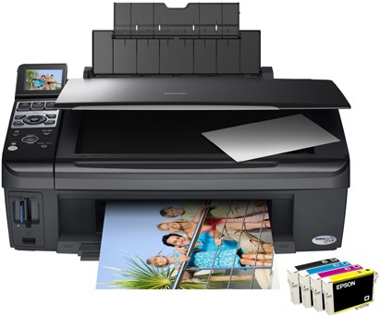
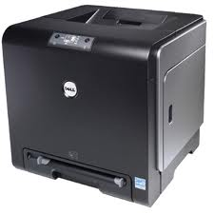

STORAGE DEVICES: These devices are used to back up information for later use.

Computer storage can be either temporarily or permanently storage media. These are categorized into two groups namely: PRIMARY AND SECONDARY MEMORY.

Let us now look at what is meant by the term primary memory this is also known as main memory. This type of storage is highly electrical and carries no moving parts. Primary memory is very fast and reliable; however, it has to be supplemented by a secondary storage device. Primary memory is divided into two types namely: RAM AND ROM (Random Access Memory and Read Only Memory).

RAM –Random Access Memory is the place in a computer where the operating system, application programs, and data in current use are kept so that they can be quickly reached by the computer's processor. However, it cannot hold data permanently (short term memory). If the user wish to store the data prepared he would have to supplement RAM with a secondary storage device (save the data) for example a flash drive.
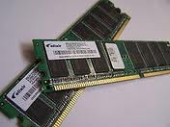

Let us now look at the on type of primary memory:

ROM - ROM is "built-in" computer memory containing data that normally can only be read, not written to. ROM contains the programming that allows your computer to be "booted up" or regenerated each time you turn it on. Unlike a computer's random access memory (RAM), the data in ROM is not lost when the computer power is turned off. The ROM is sustained by a small long-life battery in your computer.

Types of Read Only Memory

BIOS Basic Input Output System
PROM Programmable Read Only Memory
EPROM Erasable Read Only Memory
EEPROM Electrically Erasable Programmable Read Only Memory

Since we have looked at primary memory let us now look at secondary memory.

Secondary storage or memory is those devices that are used to save data for future use. The devices are not totally electrical and they have moving parts. These devices are said to have permanent storage capacity.

Such devices are as follows:

- Compact Disc (C..D-R, C.D-RW)
- Digital Video Disc
- Blue Ray
- Hard Drives
- Flash Drives
- Memory Cards, etc.

COMPUTER SOFTWARE
Software refers to a set of instructions or programmes that tells the computer what to and how to do.
Software is categorized into two main groups:
- Operating System Software
- Application Software
OPERATING SYSTEM SOFTWARE
This is a collection of instructions that co-ordinates the overall running of the computer. This type of software acts as an interface between hard-drive and the applications.
The functions of the operating system software are as follows:
- Provides a user interface
- Boot up the computer
- Manage the hardware and software of the computer
- Managing memory and scheduling jobs
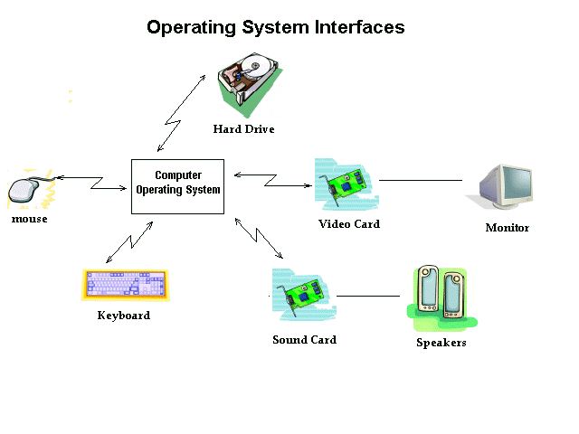
Some examples of this type software are:
- UNIX
- WINDOWS
- LINUX
- APPLLE
- DISK OPERATING SYSTEM(DOS)
- OS/2, MACINTOSH

APLICATION SOFTWARE
These are known as programmes and are used to complete a specific user task. Some task that application software may perform are typing, drawing, playing games, etc.
Some examples of application software are:
- Microsoft Office Suite
- Antivirus Programs
- Games, etc.

USER INTERFACE
The user interface allows the user and the computer to communicate. The interface provides the computer with a screen, icons, commands, buttons and instruction upon what is known as a desktop. Without the user interface the user would not be able accomplish his task.
There are three types of user interface:
- Command–driven
- Graphic-driven
- Subject-driven
COMMAND DRIVEN INTERFACE
To use a command-driven system to communicate with the computer, the user has to type in special command words. DOS, which stands for Disk Operating System, is a very commonly used command-driven user interface.
The main advantage of command driven interfaces is that they can be quick to use as long as the user knows the correct commands.
The main disadvantage of command-driven interfaces is that they are very difficult to use if the user is a beginner or doesn’t know the correct commands.
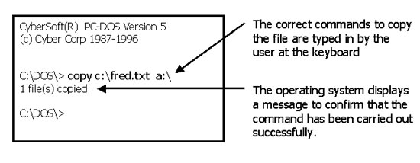
Command-driven systems can be very unfriendly and confusing for non-computer experts to use.
- Example of
command driven interface

SUJECT-DRIVEN USER INTERFACE
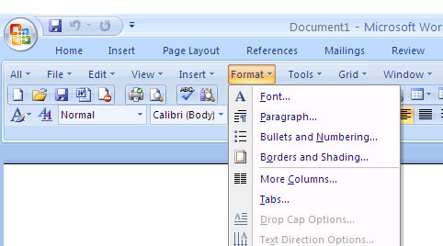
As the name suggest, with this type of user interface the user communicate by words, menus or subjects. One example of this type of user interface is the menu bar in the Microsoft Office Suite program.
- example of
subject oriented user interface

GRAPICAL USER INTERFACE

This type of user interface allows the user to communicate with the computer by the means of graphics

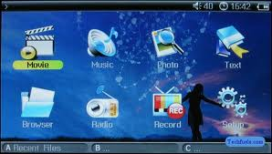
- Example of
graphic oriented user interface

CARING FOR THE COMPUTER

The computer is a very delicate piece of equipment and thus it should be taken care of properly, listed below are some ways in which you can care for your computer.
-Keep your work area clean.
- Hold disks and CD-ROMs by the edges.
-Close all programs before you shut down your computer.
-Don't bring food or drinks near your computer.
-Dust your computer and shake dirt out of the keyboard.
-Keep magnets away from your computer and disks. Magnets can erase information.
- Don’t play around the computer.
- Protect your computer from malicious software by using an up-dated antivirus program.
- Don’t drop the computer or related devices.

HEALTH AND SAFETY
When using the computer proper health and safety procedures must be followed.

HEALTH
Ergonomics is the study of people and their working environment, with a view to enhance the workplace to make it a safer place. When using the computer you the workstations should be designed to ensure that the user is comfortable when working.
These are some things that you can do to maintain proper health measures when using the computer.
WAYS TO MAINTAIN PROPER POSTURE HWEN USING A COMPUTER:

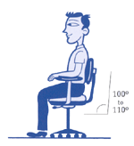 | STEP 1: Your Chair  - Push your hips as far back as they can go in the chair.  - Adjust the seat height so your feet are flat on the floor and your knees equal to, or slightly lower than, your hips.  - Adjust the back of the chair to a 100°-110° reclined angle. Make sure your upper and lower back are supported. Use inflatable cushions or small pillows if necessary. If you have an active back mechanism on your chair, use it to make frequent position changes.  - Adjust the armrests (if fitted) so that your shoulders are relaxed. If your armrests are in the way, remove them.
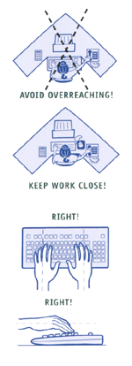 | STEP 2: Your Keyboard  An articulating keyboard tray can provide optimal positioning of input devices. However, it should accommodate the mouse, enable leg clearance, and have an adjustable height and tilt mechanism. The tray should not push you too far away from other work materials, such as your telephone.  - Pull up close to your keyboard.  - Position the keyboard directly in front of your body.  - Determine what section of the keyboard you use most frequently, and readjust the keyboard so that section is centred with your body.  - Adjust the keyboard height so that your shoulders are relaxed, your elbows are in a slightly open position (100° to 110°), and your wrists and hands are straight.  - The tilt of your keyboard is dependent upon your sitting position. Use the keyboard tray mechanism, or keyboard feet, to adjust the tilt. If you sit in a forward or upright position, try tilting your keyboard away from you at a negative angle. If you are reclined, a slight positive tilt will help maintain a straight wrist position.  - Wristrests can help to maintain neutral postures and pad hard surfaces. However, the wristrest should only be used to rest the palms of the hands between keystrokes. Resting on the wristrest while typing is not recommended. Avoid using excessively wide wristrests, or wristrests that are higher than the space bar of your keyboard.  - Place the pointer as close as possible to the keyboard. Placing it on a slightly inclined surface, or using it on a mousebridge placed over the 10-keypad, can help to bring it closer.  If you do not have a fully adjustable keyboard tray, you may need to adjust your workstation height, the height of your chair, or use a seat cushion to get into a comfortable position. Remember to use a footrest if your feet dangle.
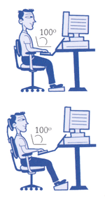 | STEP 3: Screen, Document, and Telephone  Incorrect positioning of the screen and source documents can result in awkward postures. Adjust the screen and source documents so that your neck is in a neutral, relaxed position.  - Centre the screen directly in front of you, above your keyboard.  - Position the top of the screen approximately 2-3” above seated eye level. (If you wear bifocals, lower the screen to a comfortable reading level.)  - Sit at least an arm's length away from the screenand then adjust the distance for your vision.  - Reduce glare by careful positioning of the screen.  - Place screen at right angles to windows  - Adjust curtains or blinds as needed  - Adjust the vertical screen angle and screen controls to minimize glare from overhead lights  - Other techniques to reduce glare include use of optical glass glare filters, light filters, or secondary task lights  - Position source documents directly in front of you, between the screen and the keyboard, using an in-line copy stand. If there is insufficient space, place source documents on a document holder positioned adjacent to the screen.  - Place your telephone within easy reach. Telephone stands or arms can help.  - Use headsets and speaker phone to eliminate cradling the handset.
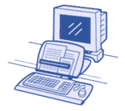  The UCLA Ergonomics site is acknowledged for this material. | STEP 4: Pauses and Breaks  Once you have correctly set up your computer workstation use good work habits. No matter how perfect the environment, prolonged, static postures will inhibit blood circulation and take a toll on your body.  - Take short 1-2 minute stretch breaks every 20-30 minutes. After each hour of work, take a break or change tasks for at least 5-10 minutes. Always try to get away from your computer during lunch breaks.  - Avoid eye fatigue by resting and refocusing your eyes periodically. Look away from the monitor and focus on something in the distance.  - Rest your eyes by covering them with your palms for 10-15 seconds.  - Use correct posture when working. Keep moving as much as possible.

